# Introduction

The Online Order Delivery System is a web-based application designed to improve order administration and delivery for APU convenience stores during the pandemic. The system requires to provide a convenient and effective method for management staff, delivery staff, and customers to interact and carry out their respective responsibilities.

The architecture of the system consists of a presentation tier, a business tier, and a database tier. The presentation tier is realised as a web application utilising JSP/JSF technologies, with JSPs containing Standard Tag Library functions and Servlets for input field validation.

The business tier is the system's foundation, containing the business logic and processes. It connects to the backend database via JDBC and Enterprise Java Beans (JEB), enabling efficient data retrieval and manipulation.

Implemented of the database tier contains all pertinent application data. It stores data regarding employees, consumers, products, orders, ratings, and comments. The database ensures the integrity of data and offers a dependable and scalable storage solution.

The system serves three distinct categories of end users: management personnel, delivery personnel, and customers. For purposes of authentication and authorization, each user must register in. The system provides each user type with the specific functionalities necessary to carry out their respective duties and responsibilities. Managing personnel have access to features including managing staff and customer information, delegating delivery staff to orders, viewing ratings and feedback, and managing product information and orders.

The delivery staff can edit their profiles, update the status of duties assigned to them, collect payments, and generate receipts. Customers can register and edit their profiles, add, delete, search for, and update product orders, as well as rate and remark on the quality of the service offered.

During the pandemic, the Online Order Delivery System provides a comprehensive solution to streamline the ordering and delivery process for the APU convenience store, facilitating efficient management and enhanced customer satisfaction.

# Components Used for the System

**MySQL Database**

MySQL Database: MySQL is an open-source relational database management system commonly used by web applications to store and retrieve data. Due to its excellent scalability, dependability, and user-friendliness, it is a good option for website developers.

**HTML**

Web pages' structure and content are generated using markup languages such as HTML. HTML is one of these formats. It is the basis upon which web pages and applications are constructed.

**CSS cascading pages**

CSS stands for "cascading style sheets," and it is a language for specifying the appearance and behaviour of web pages. It grants programmers the ability to modify the layout, typeface, and colour of HTML elements, as well as other aesthetic characteristics.

**JavaScript**

JavaScript is a client-side scripting language used to create interactive web pages and web-based applications. Sun Microsystems created the JavaScript language. It enables web developers to add functionality and interactivity to websites, such as animations, form validation, and other dynamic elements.

**AdminLTE**

AdminLTE is a Bootstrap-based admin interface template that is available for free and open-source use. It provides a variety of UI components and modules that can be used to create modern, responsive administrative interfaces. It has numerous configuration options and is easy to integrate into web applications.

**Bootstrap**

Bootstrap is a popular front-end framework used to create mobile-responsive and mobile-first web pages and online applications. It provides a selection of pre-built styles and components, that makes easier the web development process.

# Website Design

User Interface: The Online Order Delivery System's user interface should be intuitive and user-friendly, allowing users to navigate the system's features with ease. Clear labels, icons, and menus should effectively direct users. The design should prioritise ease of use and prioritise simplicity.

Visual Design: The website's visual design should be aesthetically pleasing and consistent. Appropriate colour schemes, typography, and graphics should be used to create a professional appearance. Design elements should be strategically employed to emphasise vital information and establish a distinct visual hierarchy.

Responsiveness: The design of the website should be responsive to ensure optimal usability across a variety of devices and screen sizes. The system must be accessible and operable on desktop computers, laptops, tablets, and mobile devices. To adapt to various screen resolutions, fluid layouts and media queries should be incorporated as responsive design techniques.

Forms and Input Fields: Forms and input fields should be user-friendly, with plain labels and instructions. To prevent errors and ensure the veracity of inputted data, proper validation should be implemented. Error messages should be displayed in a way that is instructive and easily understood.

Navigation: The navigation menus, breadcrumbs, and links of a system should be straightforward and user-friendly, guiding users effortlessly through the various sections and functionalities. Users should be able to swiftly locate the required information or features.

Loading Time: The Online Order Delivery System's web pages should load rapidly to ensure a positive user experience. Using techniques such as caching, minification, and image compression to optimise the website's performance can reduce loading times and increase overall efficacy.

Utilising these design principles, the Online Order Delivery System website can improve usability, functionality, and user satisfaction. Focus should be placed on developing a user-friendly interface that streamlines the order management and delivery process, thereby enhancing the overall experience for staff management, delivery staff, and customers.

# Business Tier

The business tier plays a crucial role in the Online Order Delivery System by managing application logic, data access, and user requests. It consists of the fundamental components accountable for executing business rules, administering transactions, and interacting with the data layer. The following technologies are often used in the creation of the business layer for a web-based Online Order Delivery System:

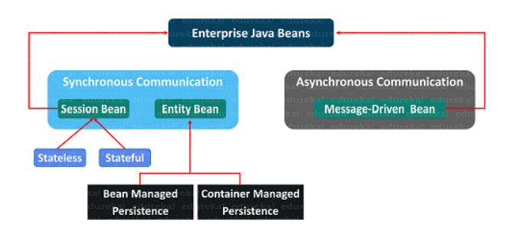

Enterprise Java Beans (EJBs): EJBs are server-side components that offer a scalable and transactional architecture for developing distributed applications. EJBs can be utilised within the context of the Online Order Delivery System to administer complex business logic and perform data access operations. They enable the system to manage duties such as staff management, customer information, order assignments, and product management.

Java Persistence API (JPA): JPA is a Java framework that facilitates the administration of relational data in a database. It uses object-relational mapping (ORM) techniques to map Java objects to database tables, enabling developers to work with objects instead of writing SQL queries directly. JPA can be used to perform Create, Read, Update, and Delete (CRUD) operations on data entities such as staff information, consumer details, product orders, and ratings in the business tier of the Online Order Delivery System.

Java Servlets: They are Java classes that process HTTP requests and responses. Commonly used in the business tier of web-based applications to manage user requests, implement business logic, and coordinate interactions among system components. Servlets can be used to process requests related to staff and customer management, order assignment, and payment collection in the Online Order Delivery System.

JSP : It is a technology that permits the construction of dynamic web pages by combining Java code and HTML. It allows developers to generate dynamic content in response to user input and data. JSP can be used to dynamically render web pages in the business stratum of the Online Order Delivery System, displaying information such as order details, product listings, feedback, and ratings.

Java Message Service (JMS): It is a Java framework that allows distributed applications to exchange asynchronous messages. It provides a dependable and extensible method for the transmission and reception of communications between diverse system components. JMS can be used to facilitate communication between various parts of the Online Order Delivery System's business tier, such as notifying delivery staff about new orders, handling payment confirmations, and generating receipts.

Using the features of EJBs, JPA, Servlets, JSP, and JMS, the Online Order Delivery System's business tier can be designed to provide scalability, dependability, and efficiency. These technologies enable the system to manage complex business processes, maintain data integrity, and provide a seamless experience for managing employees and customers.

# Data Layer

MySQL is the relational database management system (RDBMS) used by the Online Order Delivery System's data layer to store and administer the system's data. MySQL is a widely used and popular open-source database system that is renowned for its performance, scalability, and dependability.

MySQL functions as the backend database for the Online Order Delivery System, storing various types of data including staff information, customer details, product orders, ratings, and feedback. It provides a method for storing data that is structured and organised, allowing for efficient retrieval, manipulation, and querying

The Online Order Delivery System's data layer interacts with MySQL via JDBC (Java Database Connectivity), a Java API for connecting to and executing database operations. JDBC allows for seamless integration between the business logic of an application and a MySQL database.

The Online Order Delivery System ensures dependable data storage, efficient data retrieval, and robust data management by utilising MySQL in the data layer. It provides a firm foundation for the system's functionalities and contributes to the application's overall performance and efficacy.

# UML Diagram

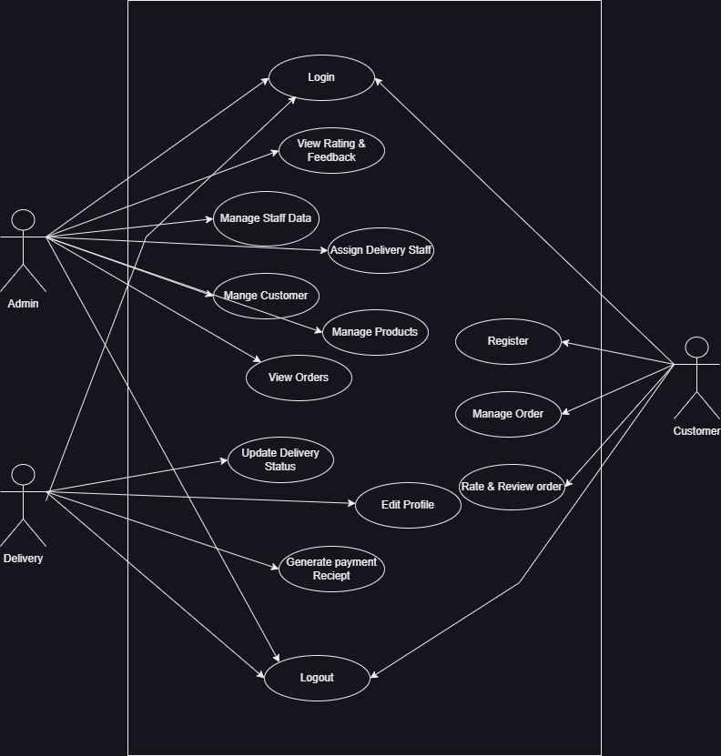

# System Overview

The Online Order Delivery System is a web-based application designed to facilitate the efficient administration and delivery of orders for a convenience store. The system seeks to provide a streamlined and user-friendly experience for managing staff, delivery staff, and customers, enabling them to interact and complete their respective tasks in a secure manner.

The system has three primary user roles: management personnel, delivery personnel, and consumers. Depending on their responsibilities in the order delivery procedure, each user role has a unique set of functionalities. Authentication and authorization mechanisms are implemented to safeguard system access.

The system includes staff and customer information management, assignment of delivery staff to orders, observing ratings and feedback, and management of product information and orders for the purpose of managing staff. They can efficiently add, delete, search for, and amend staff and customer information, as well as monitor order status.

The delivery staff has access to functions that allow them to manage their profiles, update the status of designated delivery tasks, collect customer payments, and generate receipts. They can simply track orders assigned to them, update order statuses in real-time, and ensure orders are delivered on time and accurately.

Customers can register and update their profiles, browse and order products, rate and comment on the service, and monitor the status of their orders. They can add, delete, search, and modify their product orders, allowing for a streamlined and customised ordering experience.

The architecture of the system consists of a presentation tier, a business tier, and a database tier. The presentation tier is implemented as a web application with technologies including JSP, JSF, and PrimeFaces UI components. The business tier contains the application logic and processes using technologies such as Enterprise Java Beans (EJBs), Java Persistence API (JPA), Java Servlets, and Java Message Service (JMS). Using database management systems such as MySQL, the database tier holds all pertinent data for the system.

Overall, the Online Order Delivery System offers a comprehensive solution for streamlining the administration and delivery of orders for convenience stores. The system seeks to increase productivity, customer satisfaction, and overall operational efficiency during the pandemic by integrating user-friendly interfaces, efficient workflows, and secure authentication.